CO1- OUTPUT PREDICTION
NAME: S.MAHALAKSHMI
REG NO: 192524372
COURSE:DATA STRUCTURE
COURSE CODE: CSA0311

Q1: Searching
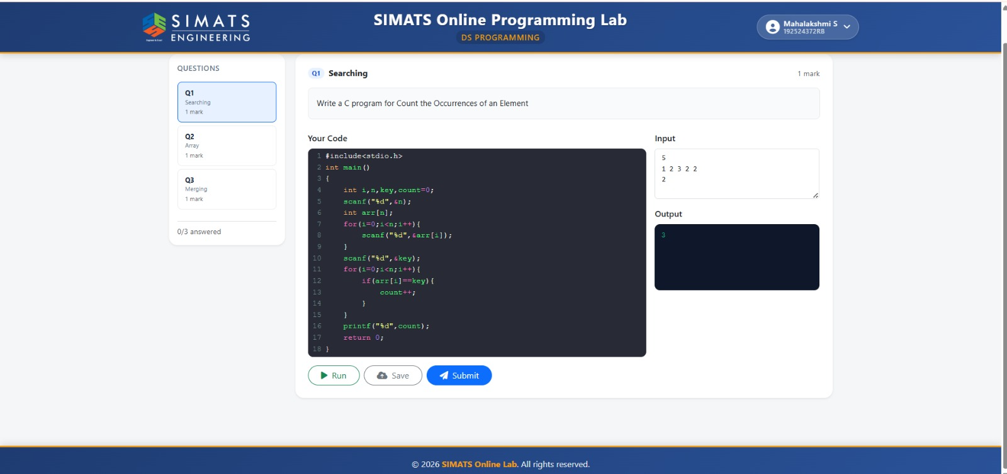

Screenshot 2 – Q3: Merging
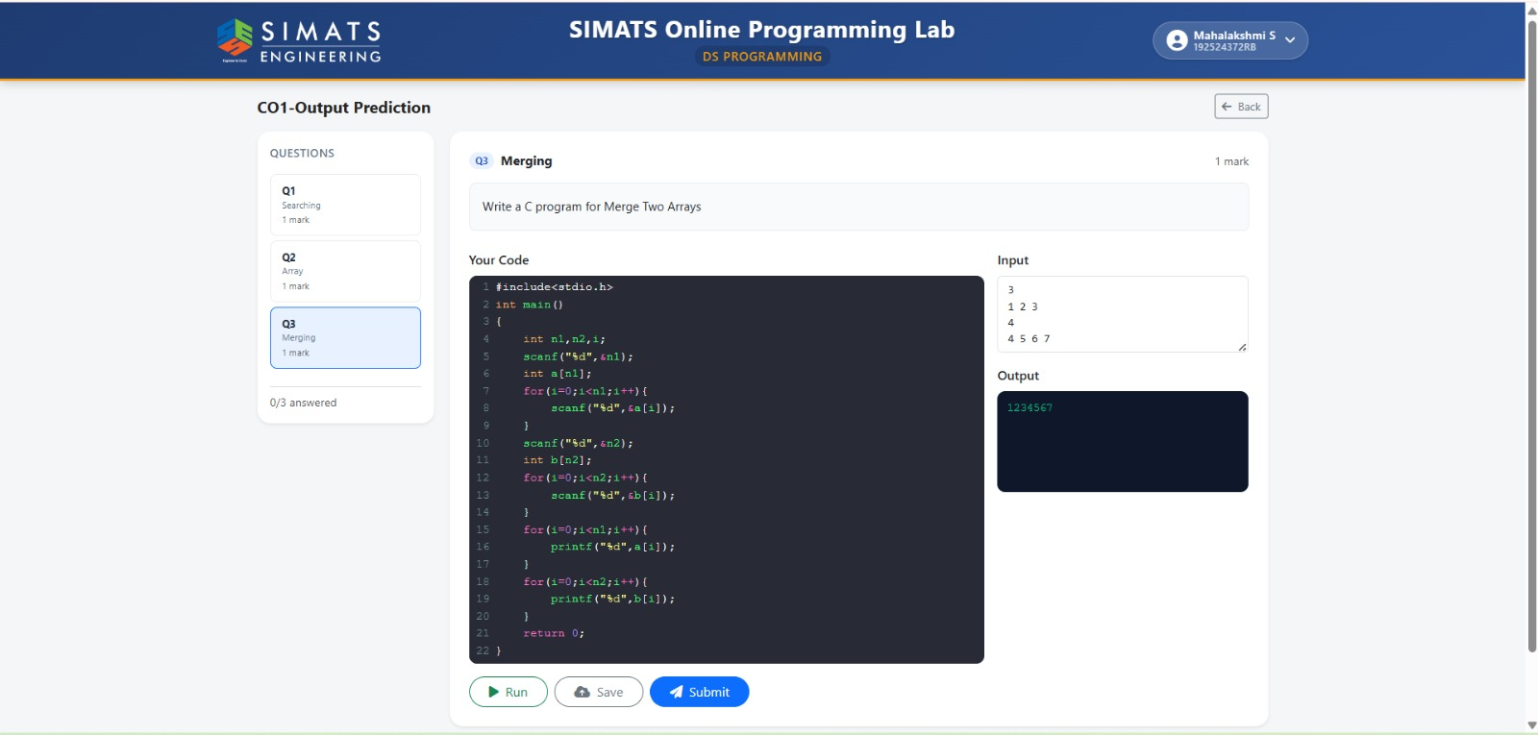

Screenshot 3 – All Questions Answered
